* **Tikaram Subedy**

**Crowdfunding Kickstarter Projects Analysis**

Crowdfunding has been raised over 2 million funds through small amount of money from large group of people either as a donation or an investment. Kickstarter is one of their projects in which the donors or investors fund the project of their choice as a kickstart. The backers may get some sort of incentives in return for example the product of the project in advance.

In this report a total of 4100 projects starting from 2009 to 2016 were analyzed on their outcomes as successful, failed or canceled. This report is prepared as part of the training on data analysis using Excel.

Looking at the categories, it is found that Theater, Music, Film & Videos are more successful compared to Food, Games and Publishing. The Technology seems like an average successful.

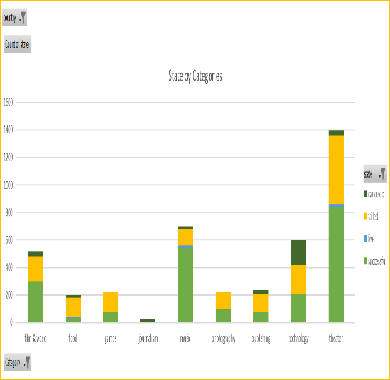

|  |  |  |  |  |  |  |
| --- | --- | --- | --- | --- | --- | --- |
|  | country | (Multiple Items) | | |  |  |
|  | **Table 1: State by Category** | | |  |  |  |
|  | **Count of state** | **Column Labels** | |  |  |  |
|  | **Row Labels** | **successful** | **live** | **failed** | **canceled** | **Total** |
|  | film & video | 300 |  | 180 | 40 | 520 |
|  | food | 34 | 6 | 140 | 20 | 200 |
|  | games | 80 |  | 140 |  | 220 |
|  | journalism |  |  |  | 24 | 24 |
|  | music | 540 | 20 | 120 | 20 | 700 |
|  | photography | 103 |  | 117 |  | 220 |
|  | publishing | 80 |  | 127 | 30 | 237 |
|  | technology | 209 |  | 213 | 178 | 600 |
|  | theater | 839 | 24 | 493 | 37 | 1393 |
|  | **Grand Total** | **2185** | **50** | **1530** | **349** | **4114** |

As illustrated in the following chart, among the sub-categories, Plays, Rock and Documentary are more successful compared to Animation, Drama, Food trucks and Video games.

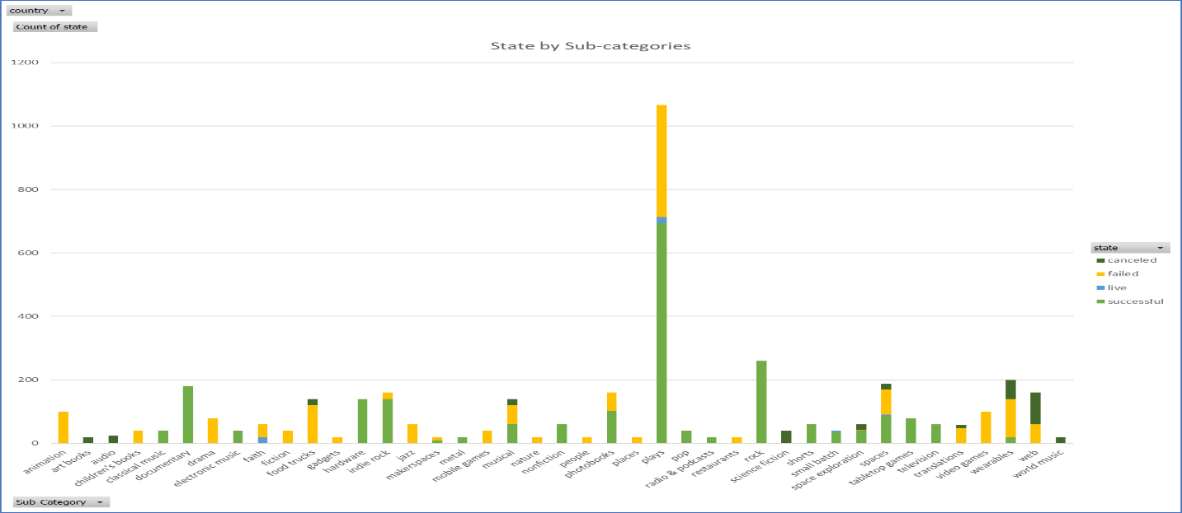

While analyzing the outcomes by months the projects began, the data showed that more projects are successful during the Spring and Fall seasons compared to Summer and Winter.

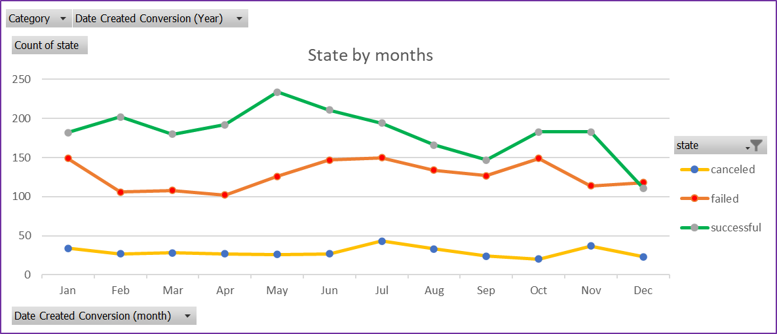

|  |
| --- |
| The given data set consists of goals in terms of different currencies, which needed to be converted into a standard form to see the standardized comparison by countries. Therefore, only percentages were compared in an interval of 5000 for training purpose. This does not reflect any real-life comparison. |
| The data showed that the projects with extremely high goals are more likely not to be successful and about 1/5 of them are canceled. The projects with moderate goals are almost equally likely to be successful or failed. |

|  |  |  |  |  |
| --- | --- | --- | --- | --- |
| **Statistics** |  |  | **Statistics** |  |
| **Successful** | |  | **Failed** | |
| Mean | 194.4 |  | Mean | 17.7 |
| Median | 62.0 |  | Median | 4.0 |
| Minimum | 1.0 |  | Minimum | 0.0 |
| Maximum | 26457.0 |  | Maximum | 1293.0 |
| Variance | 712841.0 |  | Variance | 3773.2 |
| SD | 844.3 |  | SD | 61.4 |
|  |  |  |  |  |
| In both the cases the mean summarizes the data more meaningfully than the medians. | | | | |
| The variances in both the cases are extremely high indicates that there exists skewness in the data. | | | | |
| Some remarkably successful projects with exceedingly high variation seem to be outliers which may be analyzed in a different way with a smaller sample size. | | | | |
|  |  |  |  |  |
| For the successful projects, after removing few outliers (data points higher than 5000 backers count), the variability and distributions are better explained.  Summary statistics of Successful projects (with no outliers) | | | | |
| Mean | 163.2 |  |  |  |
| Median | 61.5 |  |  |  |
| Minimum | 1.0 |  |  |  |
| Maximum | 4883.0 |  |  |  |
| Variance | 138300.7 |  |  |  |
| SD | 371.9 |  |  |  |
|  |  |  |  |  |